

LAB EXPERIMENT RECORD

SET 30

Department | Artificial Intelligence and Data Science
Course Code / Course Name | DSA0601 / Data Handling and Visualization
Name / Register Number | ROHAN P T / 192424112
Date / Day | 22/10/2026

Aim
To analyze mobile app usage analysis using the requested visualizations and dashboard views.

Dataset
Mobile App Usage Analysis
User_ID | Gender | Age | Screen_Time | App_Usage_Count | Data_Used | Satisfaction | Usage_Date
U01 | Male | 20 | 4.5 | 18 | 2.4 | 3 | 2025-01-08
U02 | Female | 22 | 6.0 | 25 | 3.8 | 5 | 2025-01-08
U03 | Male | 19 | 3.2 | 12 | 1.6 | 3 | 2025-02-11
U04 | Female | 21 | 7.1 | 30 | 4.5 | 5 | 2025-02-11
U05 | Male | 23 | 2.8 | 10 | 1.2 | 2 | 2025-03-14
U06 | Female | 20 | 5.4 | 22 | 3.1 | 4 | 2025-03-14

R Data Setup
Run this setup once before the R programs below. The dataset is defined inline so each record can be copied and run without a separate CSV file.
R data setup
dat <- data.frame(
User_ID = c("U01", "U02", "U03", "U04", "U05", "U06"),
Gender = c("Male", "Female", "Male", "Female", "Male", "Female"),
Age = c(20, 22, 19, 21, 23, 20),
Screen_Time = c(4.5, 6.0, 3.2, 7.1, 2.8, 5.4),
App_Usage_Count = c(18, 25, 12, 30, 10, 22),
Data_Used = c(2.4, 3.8, 1.6, 4.5, 1.2, 3.1),
Satisfaction = c(3, 5, 3, 5, 2, 4),
Usage_Date = c("2025-01-08", "2025-01-08", "2025-02-11", "2025-02-11", "2025-03-14", "2025-03-14")
)
dat$Usage_Date <- as.Date(dat$Usage_Date)

Additional packages used: ggplot2 (optional for styling). Install once with install.packages() if needed.

PROGRAM 1: Screen Time Histogram and Density
Import Mobile_App_Usage.csv and create a histogram with density curve for Screen_Time. Add colors, labels, and an interpretation.
R code
hist(dat$Screen_Time, probability=TRUE, col="lightblue", border="white", xlab="Screen time (hours/day)", main="Screen Time Distribution")
lines(density(dat$Screen_Time), col="#E68A36", lwd=2)

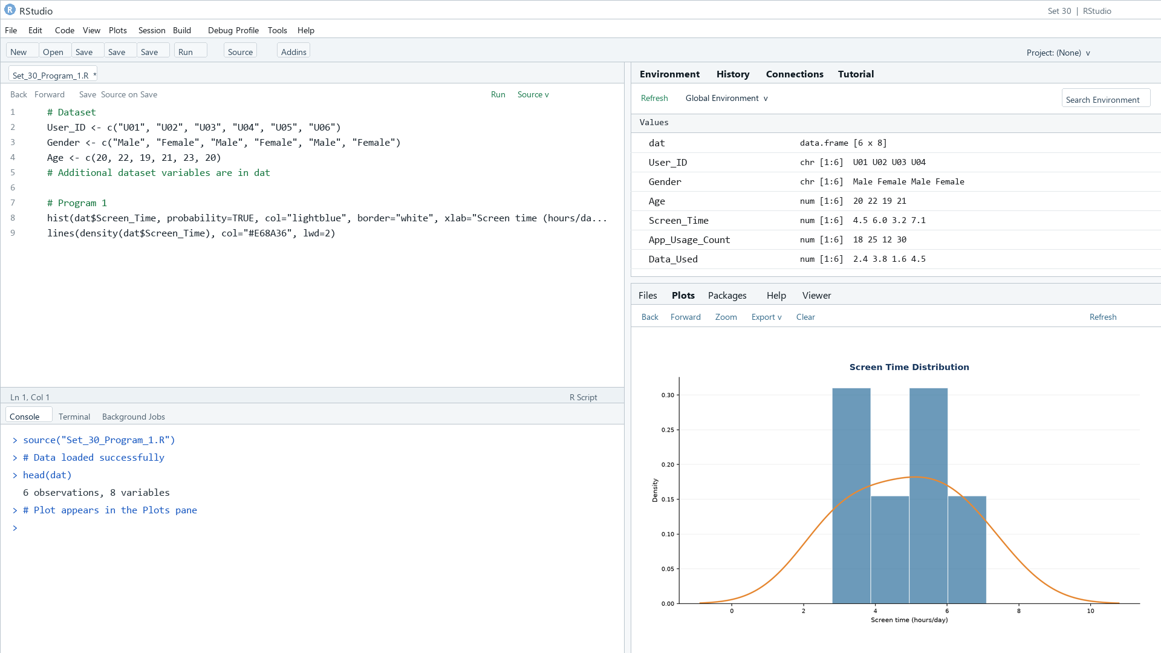
Output 1: Screen Time Histogram and Density
Observation: Screen time ranges from 2.8 to 7.1 hours per day. The sample has two higher values around six to seven hours.

PROGRAM 2: Data Usage and Screen Time
Create a scatter plot of Data_Used versus Screen_Time, calculate their correlation, add a trend line, and explain the relationship.
R code
cor(dat$Data_Used, dat$Screen_Time)
plot(dat$Data_Used, dat$Screen_Time, pch=19, col="#276B9A", xlab="Data used (GB)", ylab="Screen time (hours/day)", main="Data Used vs Screen Time")
abline(lm(Screen_Time ~ Data_Used, data=dat), col="#E68A36", lwd=2)

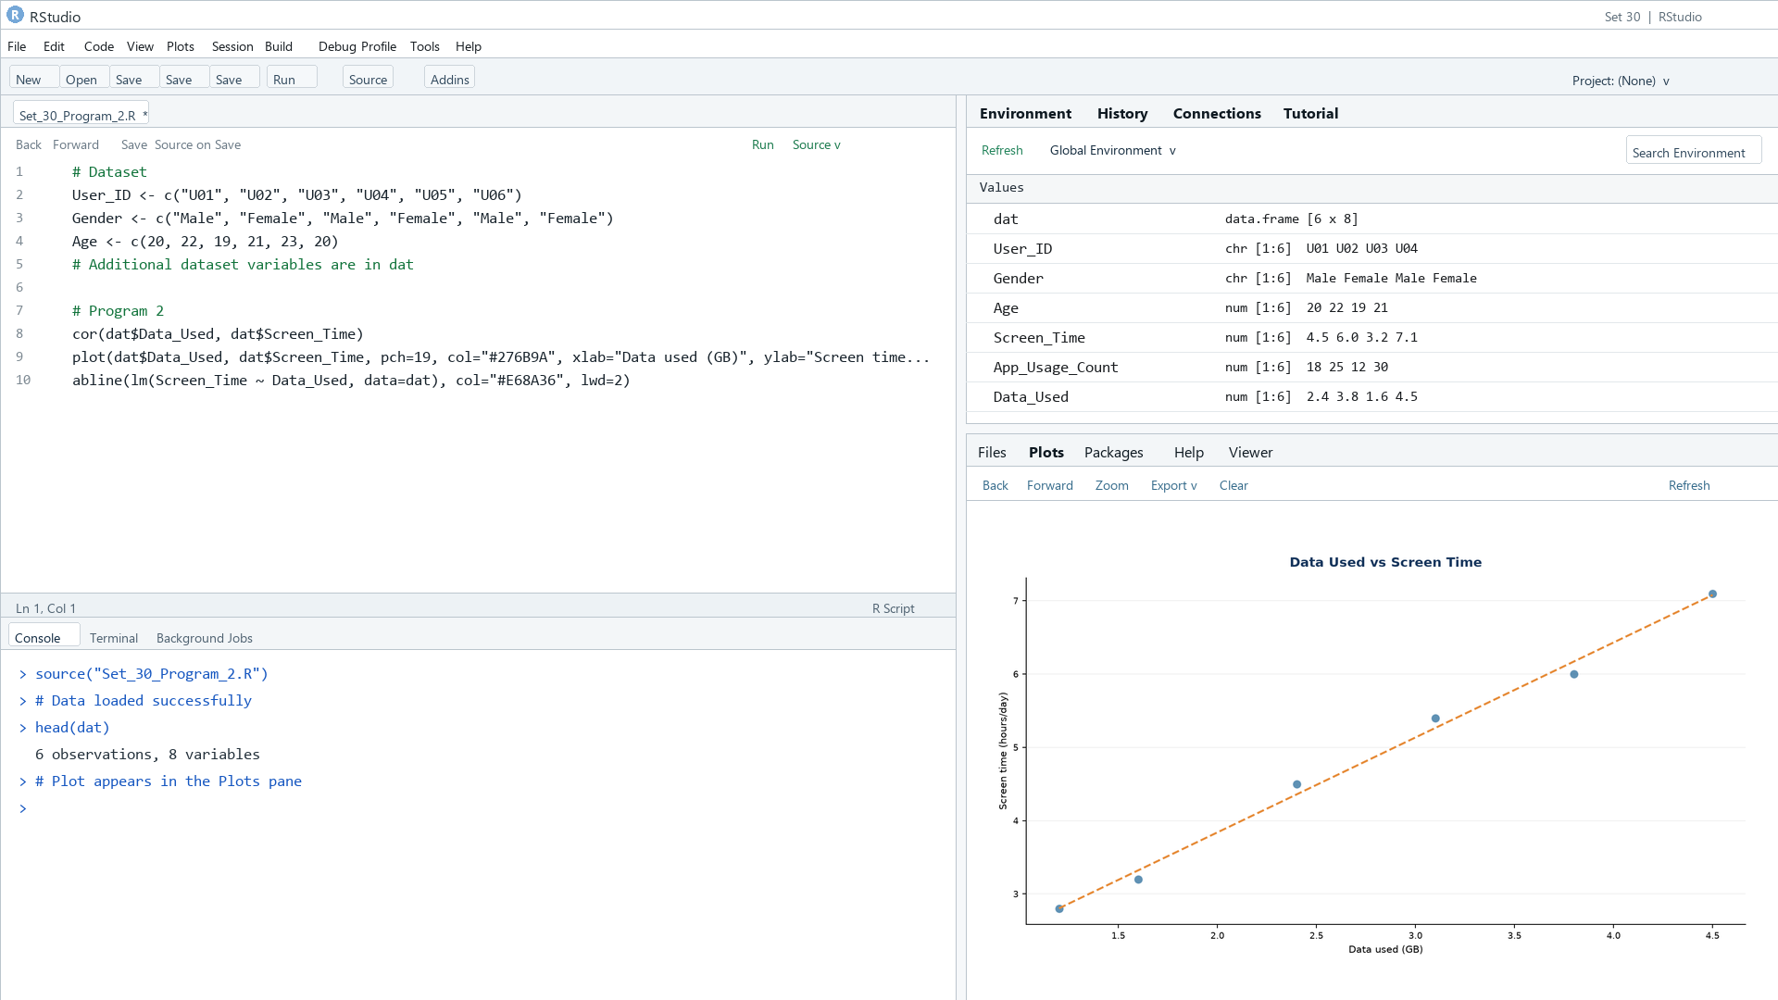
Output 2: Data Usage and Screen Time
Observation: Data usage increases with screen time in these six records; the sample correlation can be calculated in R and is strongly positive.

PROGRAM 3: Average Satisfaction by Gender
Calculate average Satisfaction by Gender and display a labeled bar chart with value labels.
R code
avg <- aggregate(Satisfaction ~ Gender, dat, mean)
b <- barplot(avg$Satisfaction, names.arg=avg$Gender, ylim=c(0,5.5), col=c("#1D8790","#276B9A"), xlab="Gender", ylab="Average satisfaction", main="Average Satisfaction by Gender")
text(b, avg$Satisfaction, labels=round(avg$Satisfaction,2), pos=3)

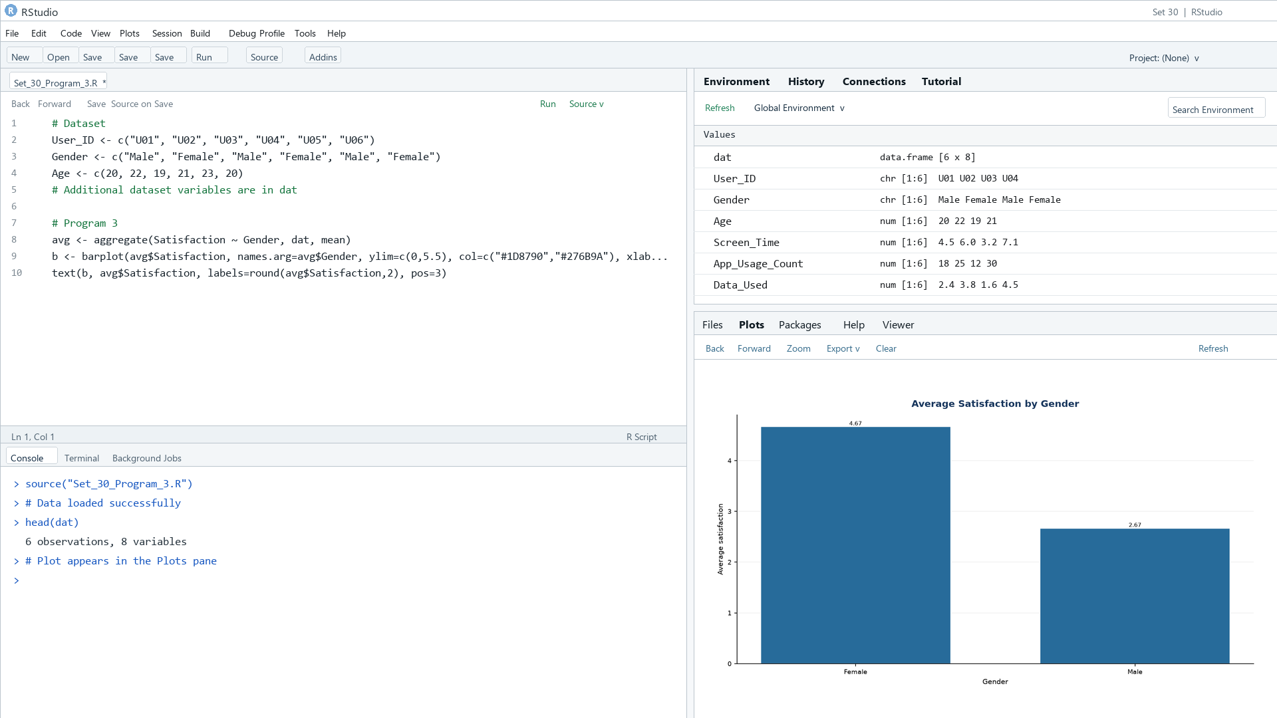
Output 3: Average Satisfaction by Gender
Observation: Female users average 4.67 and male users average 2.67 in the supplied records.

PROGRAM 4: Mobile App Usage Dashboard
Create a Tableau bubble chart of Screen_Time versus Data_Used, color by Gender, size by App_Usage_Count; add a usage trend line chart and Gender/Usage_Date filters.
Tableau build steps
Tableau dashboard build
1. Connect to Mobile_App_Usage.csv or enter the displayed rows.
2. Create a bubble chart with Screen_Time on Columns, Data_Used on Rows, Gender on Color, and App_Usage_Count on Size.
3. Create a line chart of average Screen_Time by Usage_Date.
4. Add Gender and Usage_Date filters and combine both views on a dashboard.

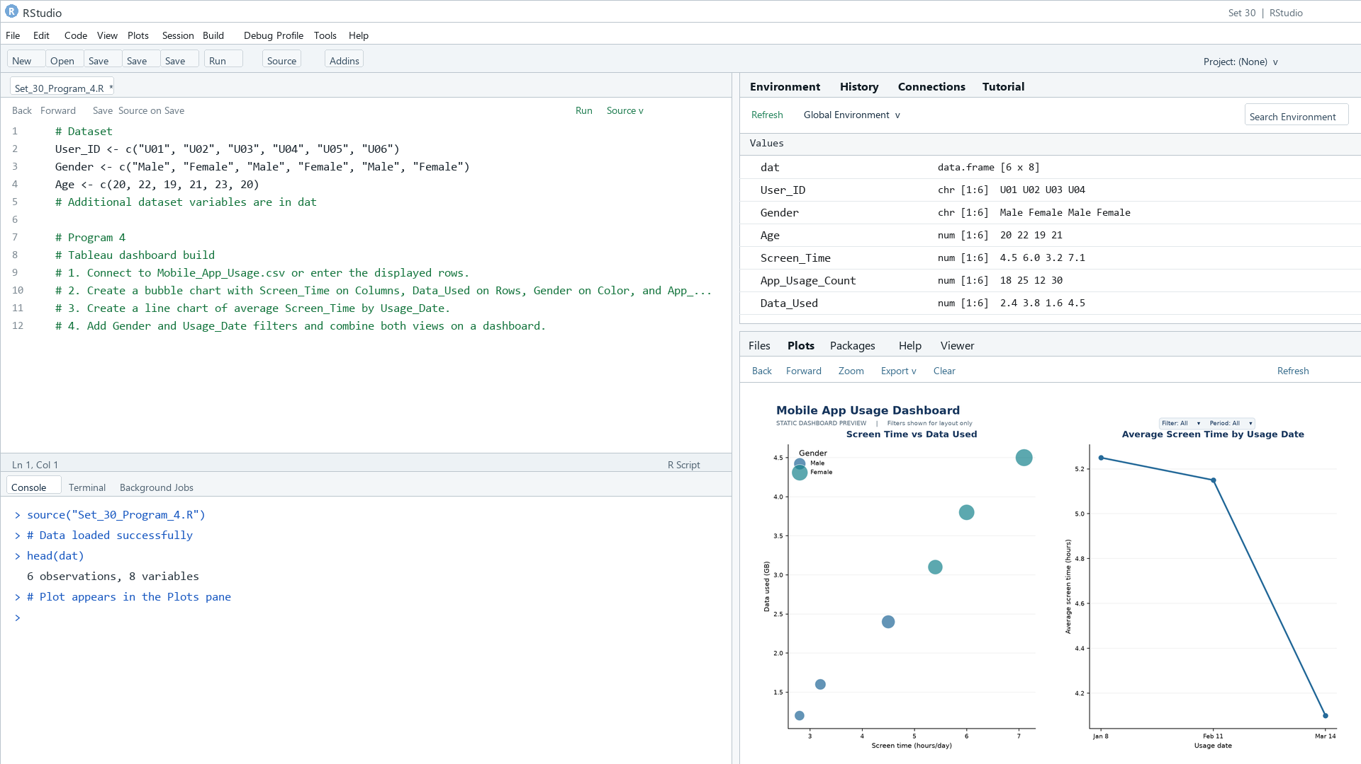
Output 4: Mobile App Usage Dashboard
Observation: The preview relates daily screen time to data volume and summarizes average screen time by date. Gender and Usage_Date filters are specified.

Procedure
1. Review the dataset table and confirm any illustrative fields noted in the record.
2. Run the R setup block once, then run the requested program code.
3. Compare the output screenshot with the observation and replace illustrative values when actual data is available.
4. For Tableau tasks, connect to the displayed data and follow the dashboard build steps.

Result
The requested charts and dashboard views for Set 30 were prepared from the displayed dataset. Outputs include labels, short observations, and code or dashboard construction steps.

Key Functions Used
plot(), barplot(), hist(), boxplot(), table().

